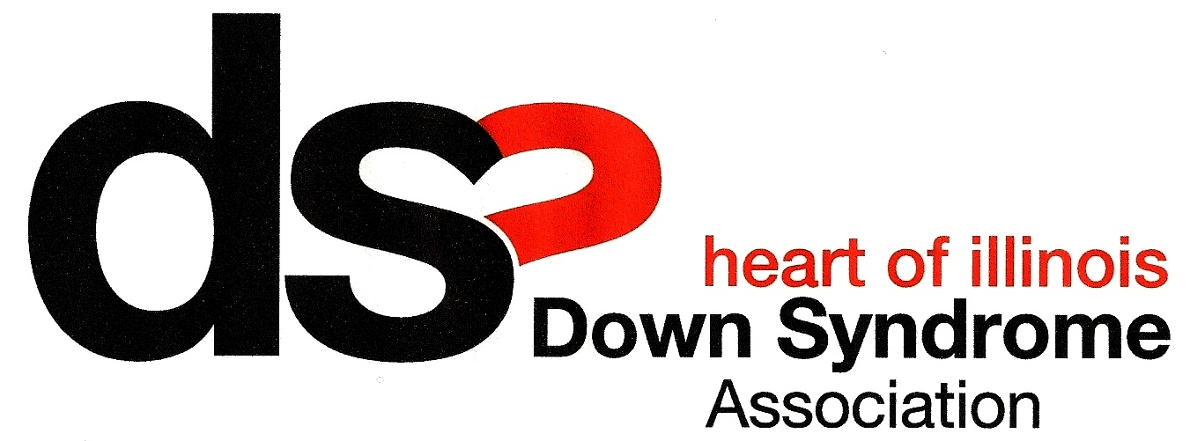

The Heart of Illinois Down Syndrome Association, Inc. budgets $5,000.00 per year and distributes family stipend funds to enable group members to attend overnight conferences of their choice that are directly related to Down syndrome or developmental disability issues.

Who can apply?
- HOIDSA family member and/or individual with Down syndrome

What can I apply for?
- Conference must be directly related to Down syndrome or developmental disabilities
- In-state or out-of-state

What can I use these funds for?
- Conference registration
- Child care
- Respite care
- Hotel
- Transportation
- Other expenses directly related to attending the conference

How much can I apply for?
- $500 per person per year
- $1000 per family per year
- Recipients are expected to participate in cost sharing of the total cost of the conference or provide a reason why they need additional support

Limitations:
- Participants are limited to a maximum of three stipends per year per individual or family within funding limit
- Stipends are granted on a first-come, first-served basis, with priority given to HOIDSA board members

How do I apply? [Any questions? Call 309.712.4852]
- The application form must be completed and returned to HOIDSA with a copy of the conference brochure and a completed registration form.
- The application must be filled out in the person(s) name attending the conference and hotel/motel information and rates should be included, if requesting.
- All applications and conference registration forms must be received 30 days prior to the date of the conference/workshop.
- Conference or workshop topics must specifically relate to Down syndrome or developmental disability issues.
- Stipends are not approved retroactively for previously attended conferences or for funds spent prior to submitting an application.

Where do I apply?
Complete the application form and mail it to the following address. A completed copy of the conference registration form MUST be submitted with the application.

Heart of Illinois Down Syndrome Association, Inc.
c/o Bethel Lutheran Church
425 N. Missouri Ave.
Morton, IL 61550

How do I learn if I get a stipend?
- Completed applications will be reviewed promptly by a review team of the group’s officers to determine whether the conference is related to Down syndrome or a development disability issue, whether the applicant is eligible for funds, and whether or not there are funds available.
- Applicants are notified by phone or in writing following the team’s decision. Applicants must provide receipts for all funds spent. A check will be sent once receipts are submitted, unless prior arrangements have been approved by the group’s treasurer.

Requirements of Stipend Fund Users:
- It is the applicant’s responsibility to make sure that the original application form is complete.
- Applications are not considered completed until the conference brochure, conference registration form, and total conference expense details are submitted.
- Recipients are expected to participate in cost sharing of the total cost of the conference or provide a reason why they need additional support.
- Funds must be used for the stated purposes.
- Unused funds, if any, are returned so more HOIDSA members can attend more conferences.
- Receipts are submitted for all expenses funded through the stipend.
- Any individual that has not provided complete documentation of and receipts for any HOIDSA Conference Stipend funds received is ineligible for further support until such documentation is provided.
- Members using stipends complete and return a post-conference evaluation form.
- Participants are expected to share with others the information received through the conference attended. If possible, please submit a review of the conference for publication in the HOIDSA newsletter.

Questions?
Call 309.712.4852

Application Form – Heart of Illinois Down Syndrome Association, Inc. Conference Stipend Fund

Name ______________________________________________ Date

Address

City _______________________________________________ Zip

Phone _______________________________ E-mail

If other family members are attending the conference, please list below:

- ______________________________________ 2.

- ______________________________________ 4.

Name of conference you want to attend:

Dates _________________________________ Location

Have you used the HOIDSA Conference Stipend Fund before?

If so, when ___________________ For what conference?

Financial Assistance Is Needed for (Enter amount needed):

Registration $__________________
Hotel $__________________
Transportation $__________________
Child Care $__________________
Respite Care $__________________
Other $__________________

Total Costs $__________________

_________ % of Total Costs you will be covering on your own.

Requested Amount $__________________ (Maximum funding is $500/person, $1000/family)

The following statement must be signed to validate this request: I am requesting assistance from the Heart of Illinois Down Syndrome Association, Inc. Conference Stipend Fund to attend a conference that I would be unable to attend without this support. I promise to use the funds for the stated purposes and to submit receipts for all expenditures funded through this stipend. I will also complete a post-conference evaluation form.

Signature

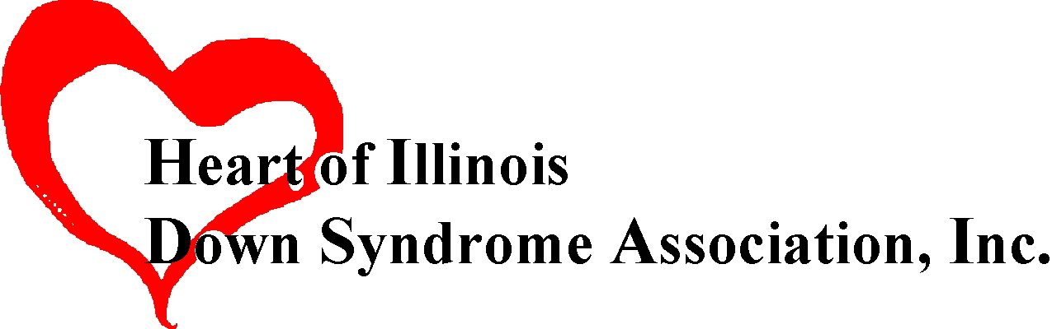
Provide the names of everyone who ATTENDED the conference or workshop from stipend request:

Name ________________________________________ Name

Name ________________________________________ Name

Provide the name(s) of family member(s) with Down syndrome:

Name ________________________________________ Name

Name of conference or workshop:

Event date:

- Overall, how satisfied were you with the conference? (Please circle one)
Very Satisfied Satisfied Somewhat Satisfied Dissatisfied Very Dissatisfied

- What skills did you hope to gain from attending this conference? (Circle all that apply)
a. Improved understanding of medical issues
b. Increased knowledge of advocacy
c. Better understanding of special education system
d. Better understanding of rights of people with Down syndrome and/or developmental disabilities
e. Other

- What are the two most helpful things you learned at this conference/workshop?

1.

2.

- How did you share what you learned at the conference with others? (Circle all that apply)
a. Writing a newsletter or newspaper article | b. Discussion at group meeting
c. Sharing information with family members | d. Sharing information with service providers
e. Other _______________________________

- How did attending this conference enable you to make a change in your life?

- Would you have attended this conference without the stipend? ____Yes ____No

- Did you receive any other assistance to attend this conference: (Circle all that apply)
a. Conference registration fee waived | b. Conference scholarship
c. Local or state agency reimbursement | d. Another conference financial aid program

e. Other _______________________________

- Did you receive your stipend check in a timely manner? ____Yes ____No

- How would you rate the HOIDSA Conference Stipend program? (Please circle one)
Very Satisfied Satisfied Somewhat Satisfied Dissatisfied Very Dissatisfied

- Have you used the HOIDSA Conference Stipend in the past? ____Yes ____No

- How could we improve the application process?

- Additional comments:

Please attach any additional receipts from the conference/workshop and return this evaluation form to:

Heart of Illinois Down Syndrome Association, Inc.
c/o Bethel Lutheran Church
425 N. Missouri Ave.
Morton, IL 61550

March, 2006

